**Linear Algebra**

1. **Introduction to Vectors(2-D, 3-D, n-D) , Row Vector and Column Vector**

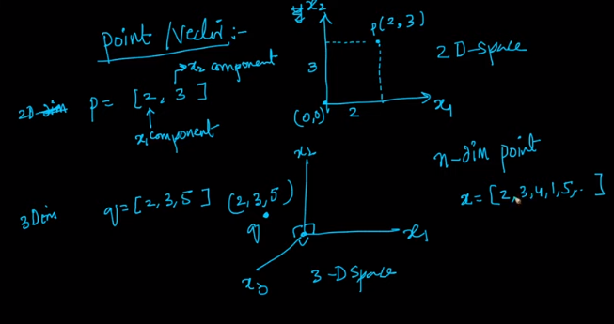

It describes how 2D , 3D and n-D points are representated.

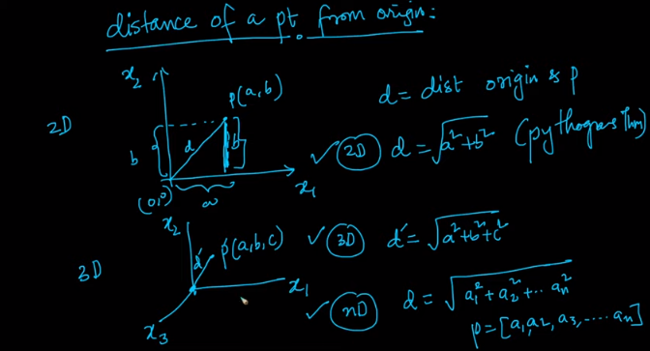

It explains distance of a point from origin in 2D, 3D and n-D space and its formula.

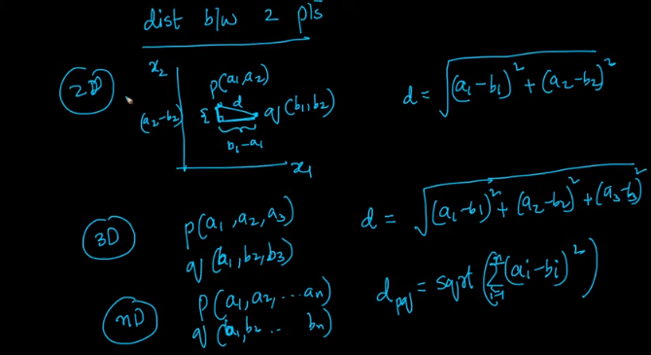

It explains distance between 2 points using Pythagoras theorem (Distance formula) .

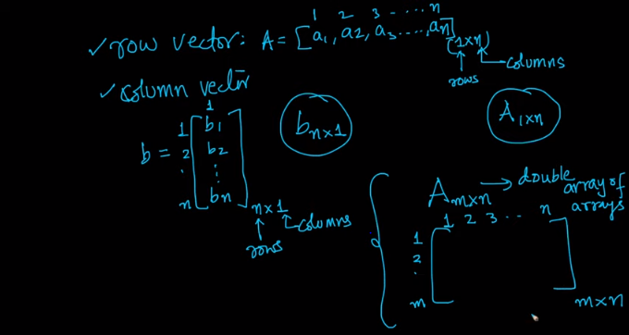

It explains how to represent vectors as row vector and column vector.

1. **Dot Product and Angle between 2 Vectors**

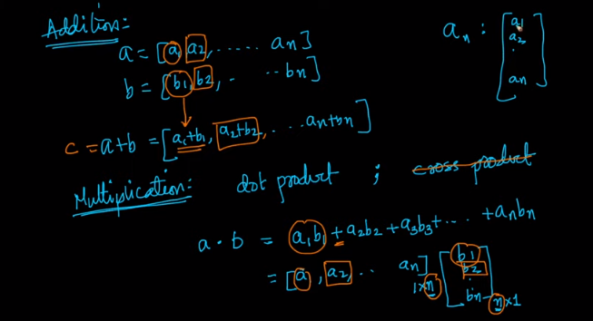

It explains Addition and Multiplication of Vector. Multiplication of Vector can be done using Dot Product and Cross Product. Here, we will purely focus on dot product of vectors.

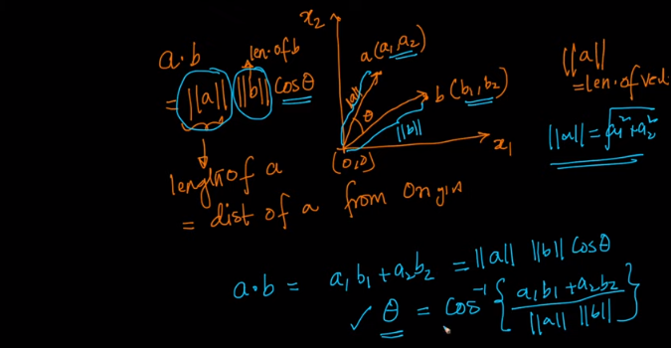

It explains dot product of vectors a and b can also be written as a.b = ||a|| ||b|| . cos(theta) . This helps in understanding the geometric intuition.

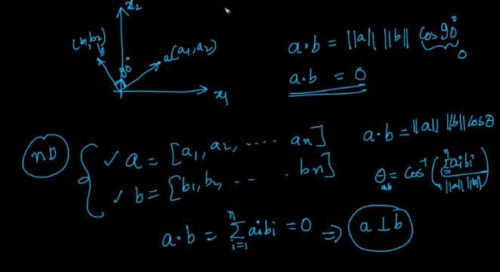

It explains dot product of a.b when a is perpendicular to b , is 0, as cos 90 is 0.

1. **Projection and Unit Vector**

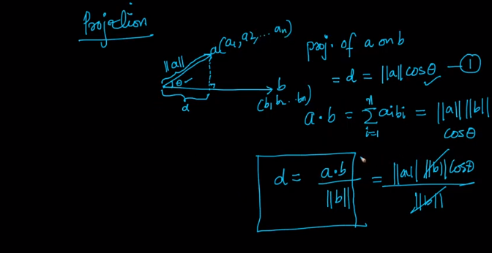

It explains how to derive projection of a vector a on vector b. The mathematical details can be understood by referring notebook page no. 4.

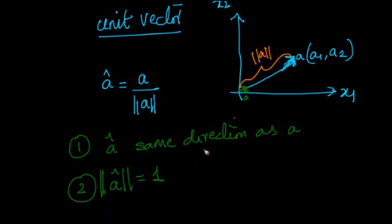

It explains the concept of unit vector.

1. **Equation of a line (2-D), Plane(3-D) and Hyperplane (n-D), Plane Passing through origin, Normal to a Plane**

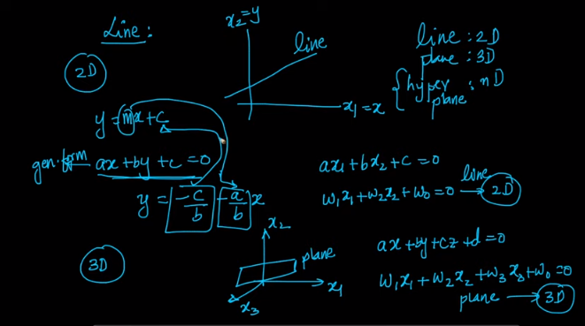

It explains equation of line, plane and hyperplane passing through origin. For more information refer notebook pg no. 5

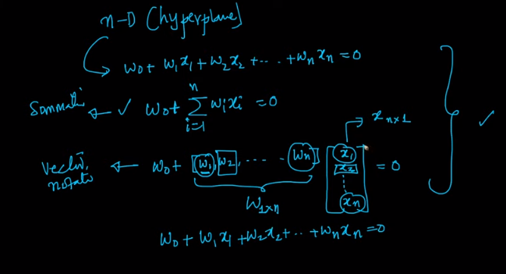

It explains conversion of equation into vector form to also understand the geometric intuition. For more information refer pg no. 6.

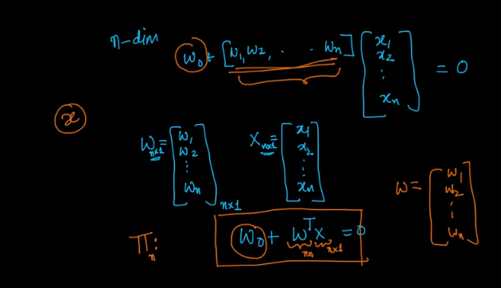

Refer notebook pg no. 7.

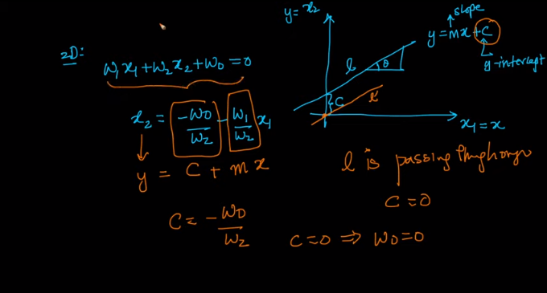

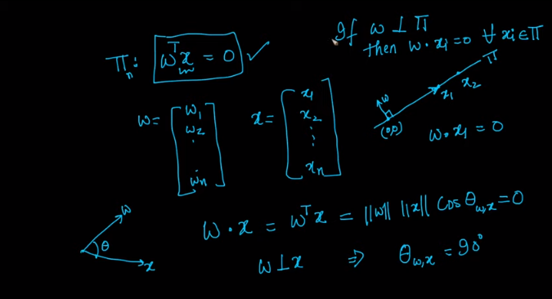

Refer notebook pg no. 7.

1. **Distance of a point from a Plane/Hyperplane, Half-Spaces**

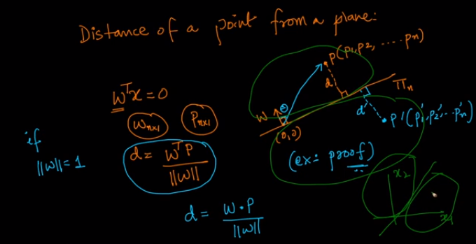

It explains distance of point from a plane. For more information refer notebook pg no. 8 and 9.

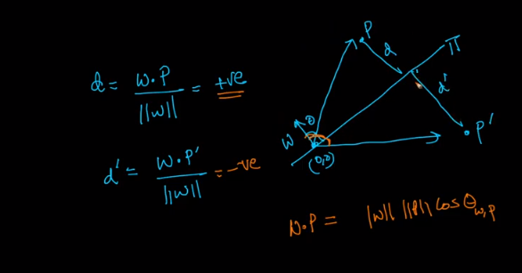

1. **Equation of a Circle (2-D), Sphere (3-D) and Hypersphere (n-D)**

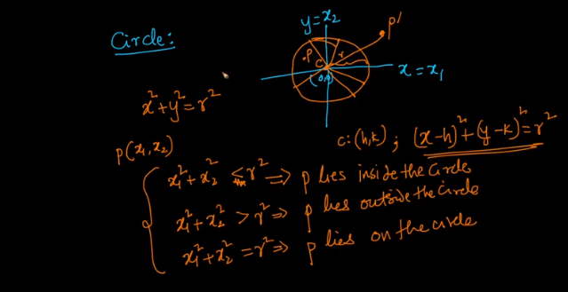

Refer notebook pg no. 10.

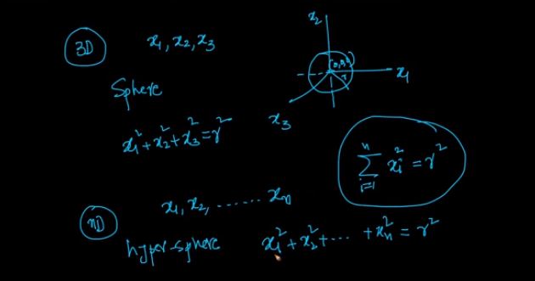

Refer notebook pg no. 11

1. **Equation of an Ellipse (2-D), Ellipsoid (3-D) and Hyperellipsoid (n-D)**

